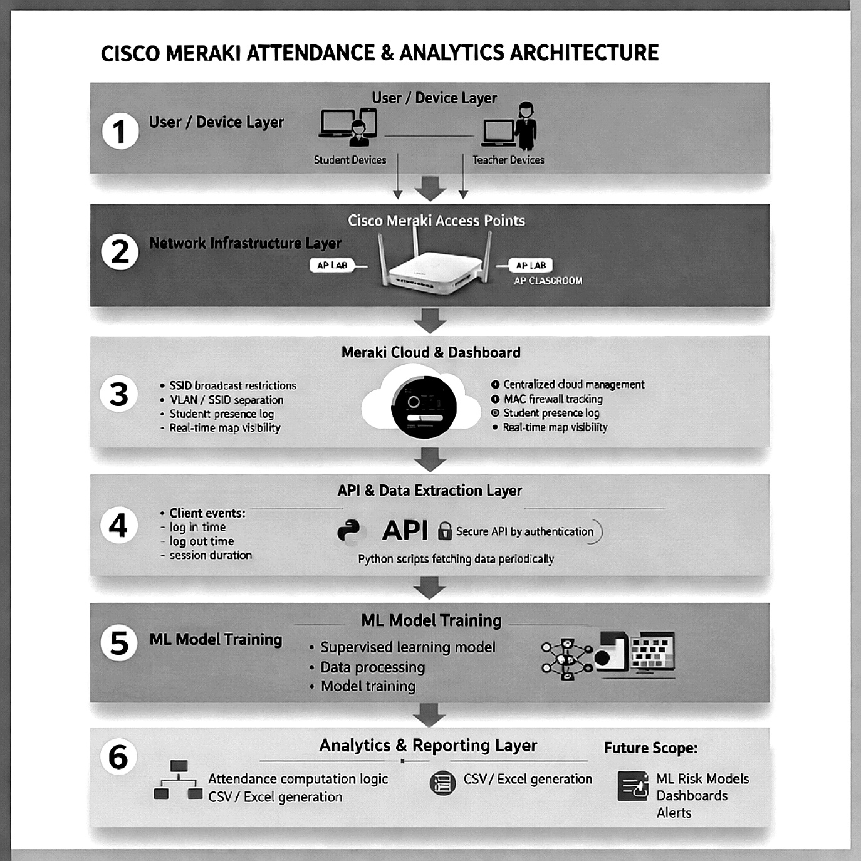

Data Gathering
We called out the students and got the real time data gathered required for the model training and future analysis part as well. We used API key from the Cisco Meraki Dashboard to extract the data using python scripts we gathered and segregated the data as per our requirements.

Subject | Client | Month | Total_Subject_Minutes | Total_Attended_Minutes | Monthly_Attendance_Percent | Risk_  Status
DSA | Mobile-1 | 1 | 800 | 102 | 12.75 | HIGH RISK
DSA | Mobile -2 | 1 | 800 | 594 | 74.25 | Moderate Risk
DSA | Mobile -3 | 1 | 800 | 632 | 79 | No Risk
Data Pre processing
Now the Data is extracted in the form of CSV file, the next process was to integrate the csv files into the excel files and then from the excel file we start taking the data we do the preprocessing of the data.
Here the extracted data contains the login time , logout time , the bandwidth , the mac address and the client name .Using the login time and the logout time we can calculate the duration how much time the student is actually present in the class.
Formula: [Logout time – Login Time ] = Duration present
We can calculate the duration of the student but to actually know whether the student is actually present is by considering the usage of the student . Here where Bandwidth column comes into play , As the students will be using their device through out the class duration so the bandwidth of the students using it from the beginning will have a same frequency channel but a slight fluctuations plus or minus of the graph , but the student who used in the beginning and not using at the middle till the end the graph or the channel of the device falls down , and if the student bandwidth is comparatively higher than the other ones we can consider them that the student is undergoing some malicious behaviour which must not be done .
Fig:1.1

Here we have the columns named from the above figure [Total_Subject_Minutes] which indicates the total number of minutes the classes has happened in the whole month duration , accordingly we have the following columns [Total_Attended_Minutes] how much time the student has attended in the whole week, and we have the [Monthly_attendance_percentage ]which gives the percentage of the student according to the particular month . Next, we have the column the [Risk_Status] this talks about the status of the student whether he should be considered or informed when he is having High and Moderate risk according to his percentage. The risk status is calculated in three ways they are:
if percentage < 50:
return "HIGH RISK"
elif percentage< 75:
return "MODERATE RISK"
else:
return "NO RISK"

The below image shows a representation of the total over view of the model how the predictionsa re done and the output and how the data is being segregated in graph as per subject and in different levels of risk status.
